Name:__________________________________________ Date:__________ Block ________________

* **SOLVE & CHECK EACH EQUATION.**
* **Be sure to show your steps for solving each problem, line by line**
* **Watch your signs**
* **Circle all answers, please!**

Move Variables from Right to Left

Combine Like Terms

Distributive Property

Check Answer

Undo Multi/Div

Undo Add/Subtr.

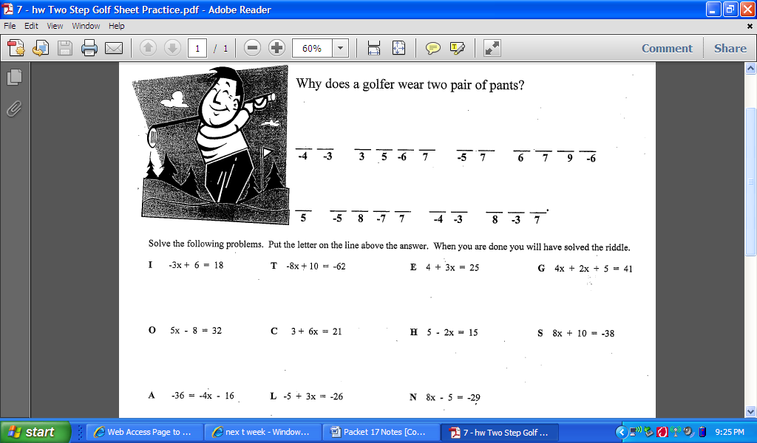

**Homework – Solving Equations**

Solve & Check:

1.  __________
2.  __________
3.  ___________
4.  __________
5.  ___________
6.  __________
7.  __________
8.  ___________
9.  _________