### Name: __________________________________________ Date: _____________________________

**Reflections Notes and Classwork**

**Reflect across y = x:**

 Switch the order of the coordinates.

**Reflect across y = -x:**



Switch the order of the coordinates and change the sign of the ______________________.

Find the coordinates of the vertices of each figure after the given transformation.

1. Reflection across y = x.



1. Reflect across y = x.



1. Reflect across y = -x.



1. Reflect across y = -x.



1. Reflect across y = x.



1. Reflect across y = -x.



1. Reflect the image.

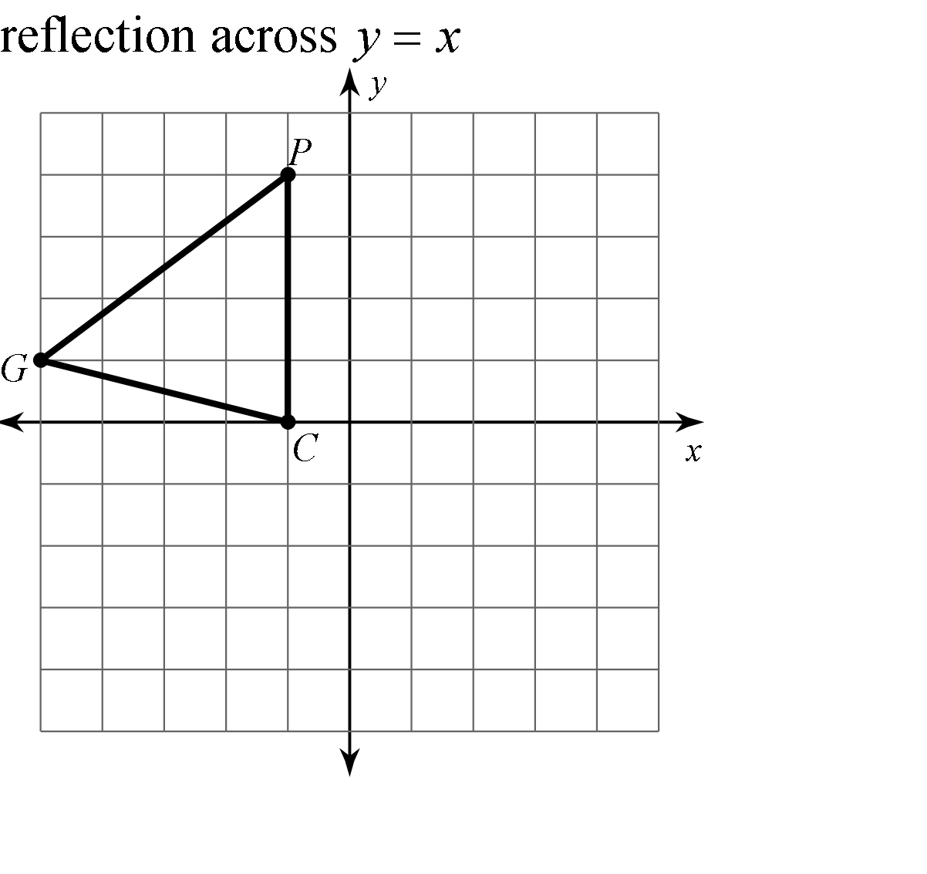

9. Reflect the image 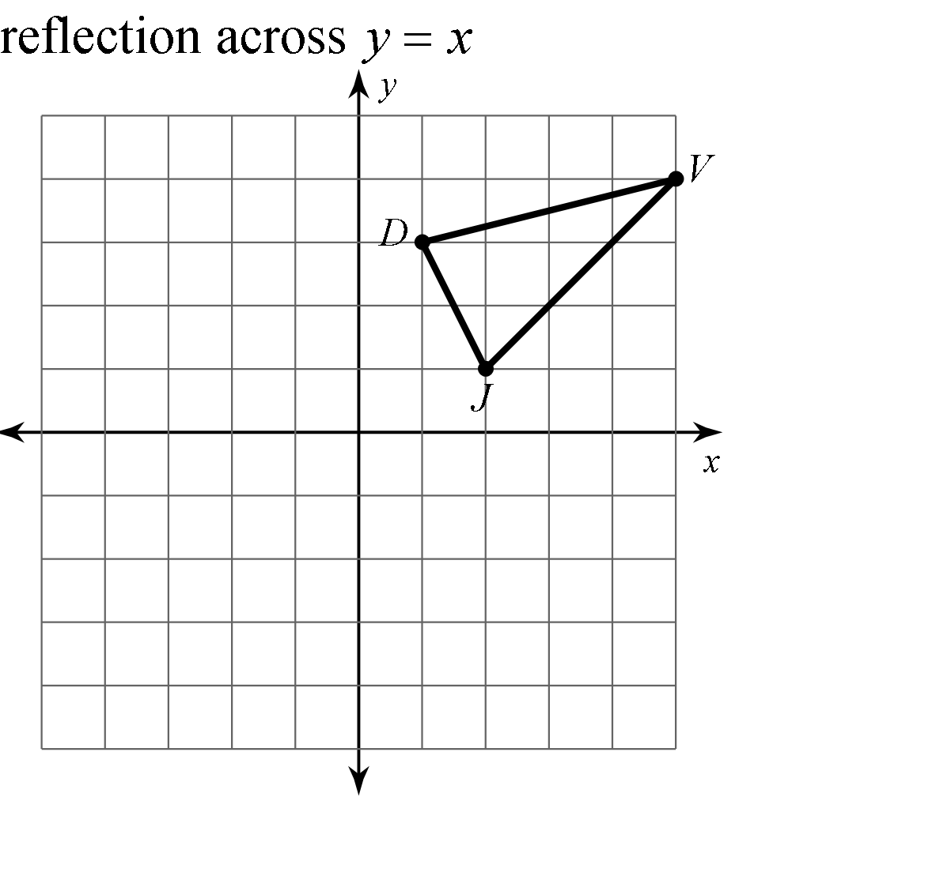

11. Reflect the image.

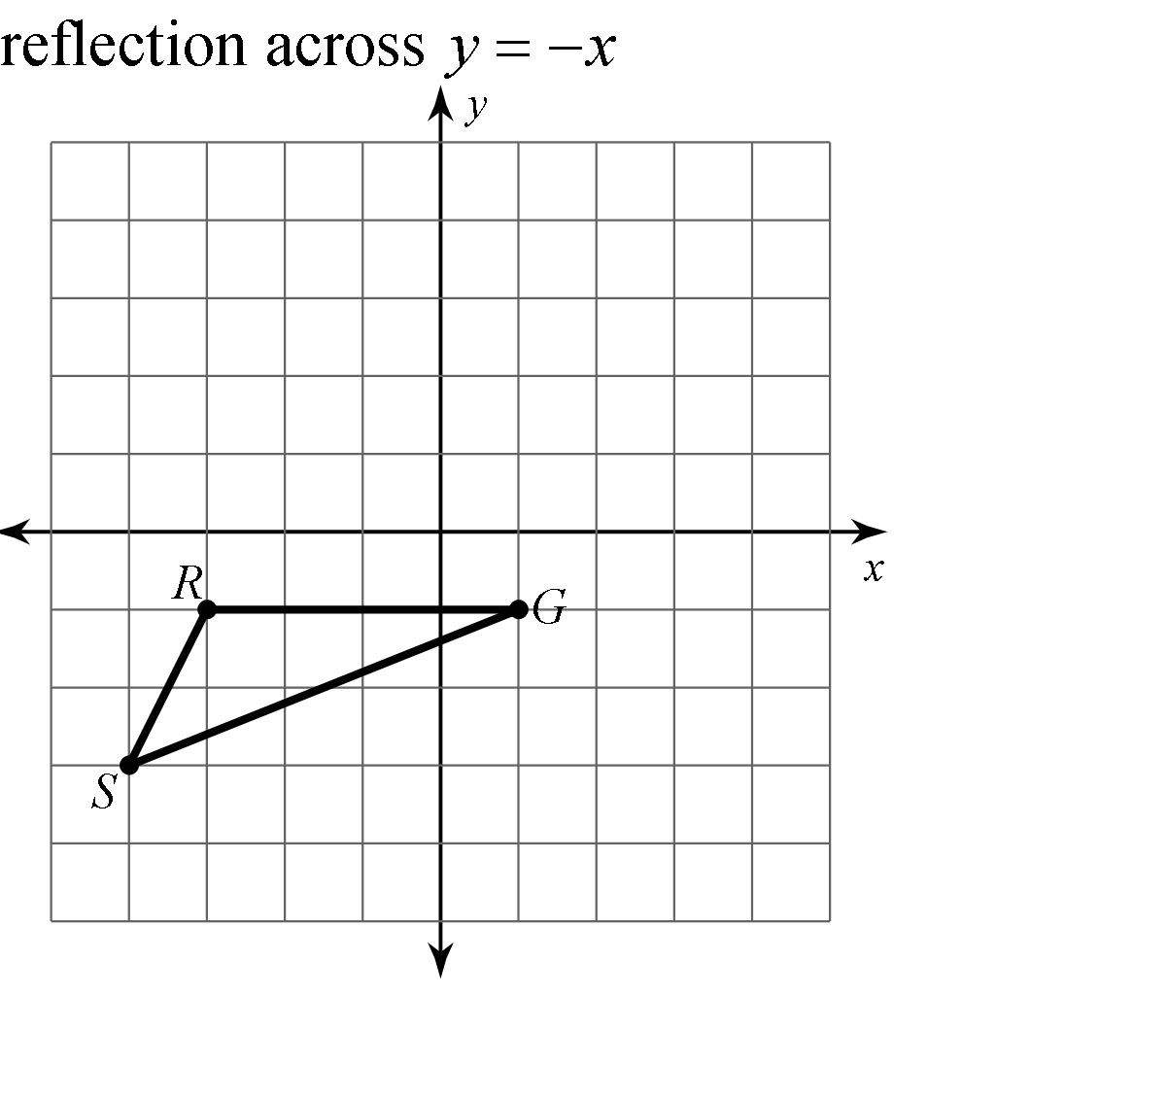

1. Reflect the image

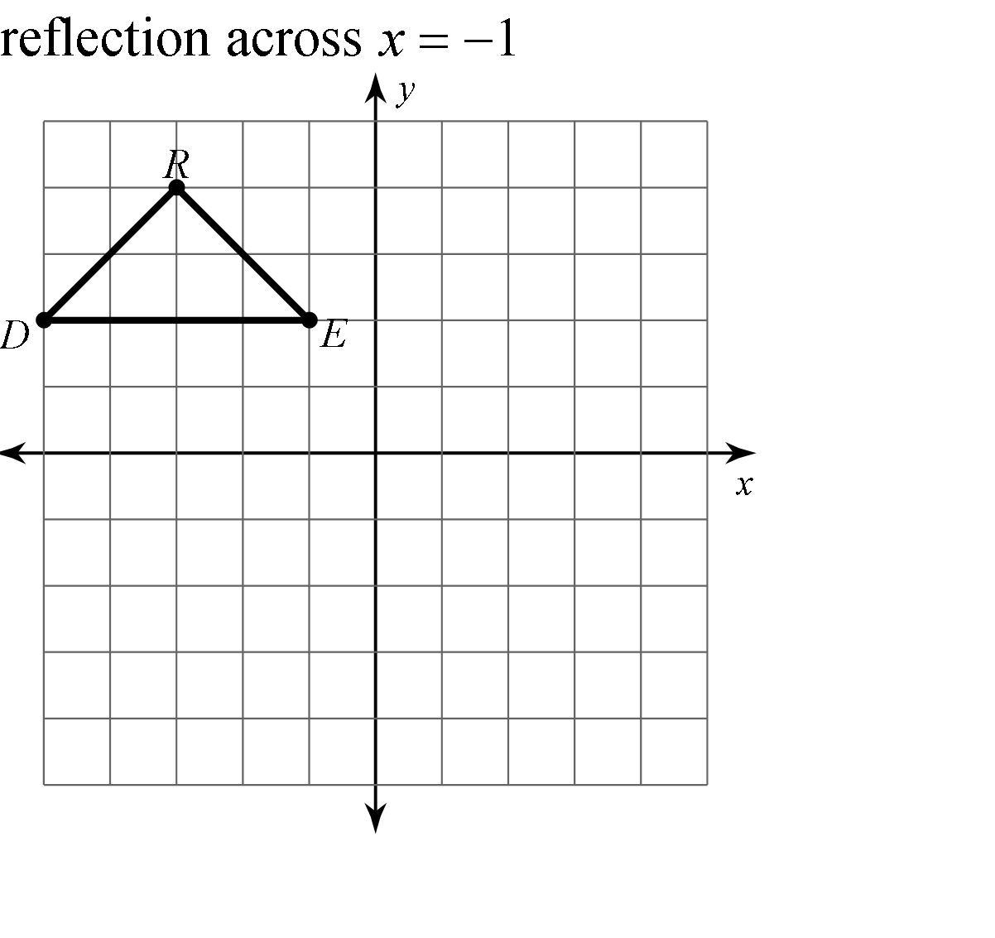

10. Reflect the image

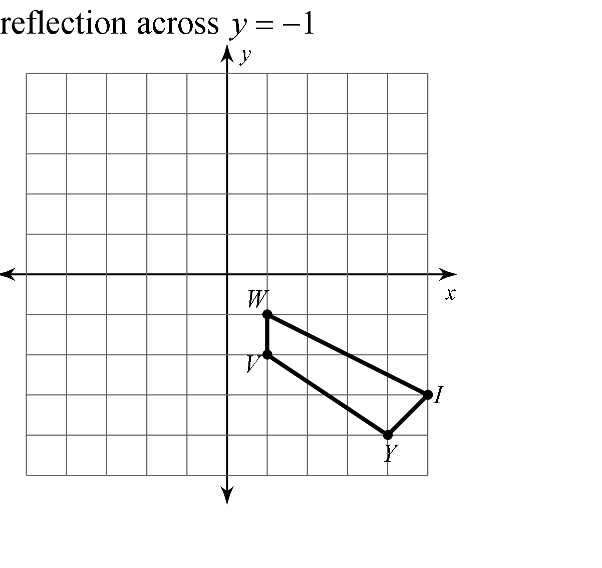

12. Reflect the image 