Name: _______________________________________ Date: ________________________________
Exterior Angle Theorem
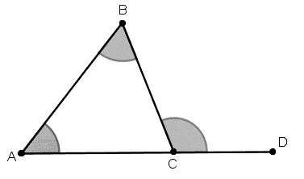
The measure of an ______________ angle of a triangle is equal to the _______ of the measures of the two _______________ interior angles of the triangle.
_______ + _______ = ________
3
2
1

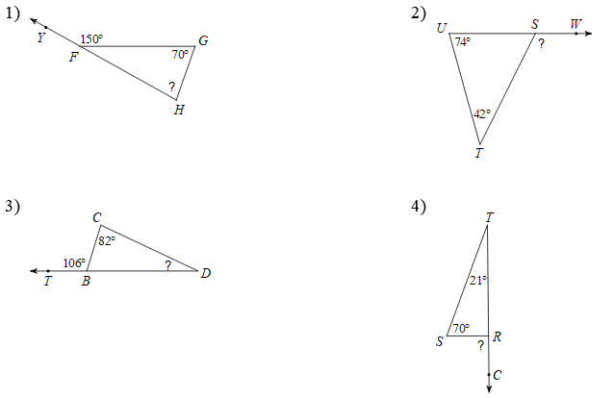
Solve for the missing angle.

Solve for x.

Base Angles and Exterior Angle Theorem Practice
