### Name: __________________________________________________________ Date: ____________________________

**Rotations Practice**

1. **Where will the L-Shape be if it is…**

a. rotated 90° **clockwise** around the origin? b. rotated 270° **clockwise** around the origin?



1. Rotate each figure about the origin using the given **clockwise** angle**.**

a. 270° b. 180° c. 90°

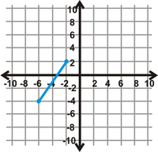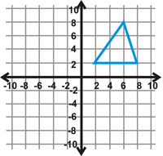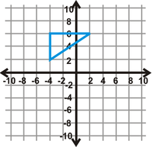

1. Rotate each figure about the origin using the given **counterclockwise** angle**.**

d. 180° e. 270° f. 90°

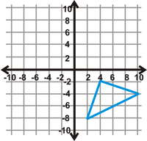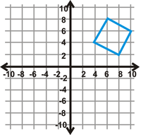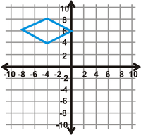

1. Rotate each figure about the origin using the given angle**.**

a. 180° clockwise b. 90° counterclockwise c. 270° clockwise



d. 180° counterclockwise e. 90° clockwise f. 270° counterclockwise



1. Reflect each figure across the given the line**.**

a. y= -2 b. y-axis c. y = x

