Name: ________________________________________________ Date: _______________________

**Dilations**

* In a dilation, we are just __________________ the image.
  + Dilations are NOT an ____________________.
  + When we dilate an image, the ________ change, the ________ do not.
  + This is the one transformation where the pre- image and image are _____________, but not _____________.

**Scale Factor:**

* We use “k” to represent _________ ___________.
* We ___________ by k to find the image.

|  |  |  |
| --- | --- | --- |
| **If…** | **We call it…** | **The shape gets…** |
| 0 < k < 1 |  |  |
| k = 1 |  |  |
| k > 1 |  |  |

Determine if the scale factor represents a reduction, enlargement, or congruence.

1. k = 1/3 b. k = 2.5 c. k = 50% d. k = 200%
2. Dilate the image by k=2.



1. Dilate the image by k= ½.



1. Dilate the image by k = 2.

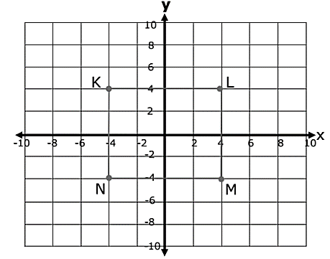

1. 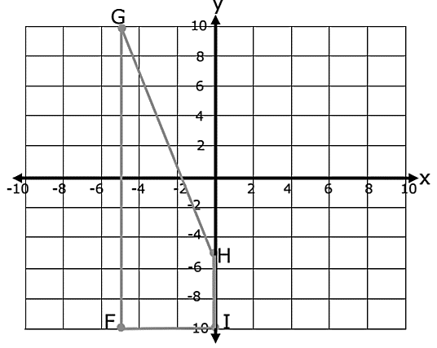Dilate the image by k = 1/5