Name: _________________________________________ Date: ________________________________

Triangles – Inequalities
Triangle Proofs!!!
Angle Sum Theorem  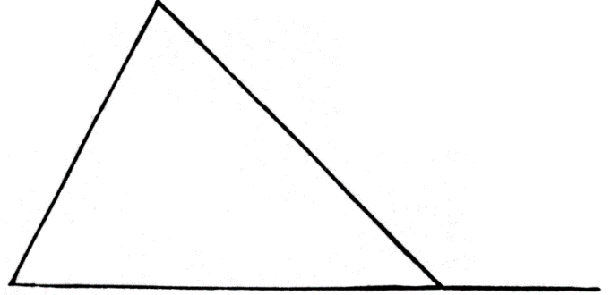  B  C  A | Exterior Angle Theorem  D  C  B  A

The sum of the lengths  of any two sides of a  triangle is greater than the length of the third side. | 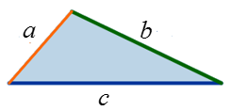

Are these possible side lengths of a triangle?

- 10, 10, 6
- 1, 7, 8
- 6, 18, 9

What is the range of possible side lengths for the third side?

- 10, 11
- 6, 8
- 12, 7

The shortest side of a triangle is opposite the smallest angle.  The longest side of a triangle  is opposite the largest angle. | 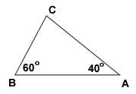 | List the sides from  shortest to longest!

List the sides in order from least to greatest:
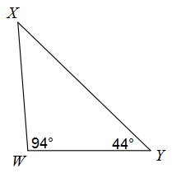

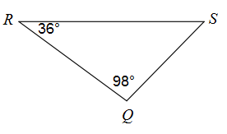

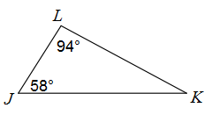

List the angles in order from least to greatest:

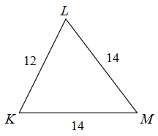
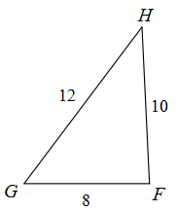
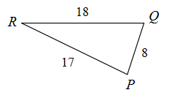

Acute Triangles | Right Triangles | Obtuse Triangles
b  a  c | c  a | c  a  b
 | b

Classify each triangle as acute, right or obtuse.

