Name: ____________________________________ Date: _________________________

Use the following to review for you test. Show your work on a separate sheet of paper if needed.
Things to Know | Things to Remember | Examples
Properties of Parallelograms | - Opposites angles are congruent  - Consecutive angles are supplementary  - Opposite sides are equal  - Diagonals bisect each other | - Find x and y. | - ABCD is a parallelogram. Find x. 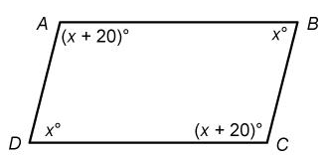
 |  | - Find x and y. | - Find x and y.
Special Parallelograms | - A rectangle is a parallelogram with 4 right angles,  - A rhombus is a parallelogram with 4 congruent sides.  - A square is a rectangle and rhombus | - Find x and y. | - NPQM is a rectange. Find x and angles 1 & 2.  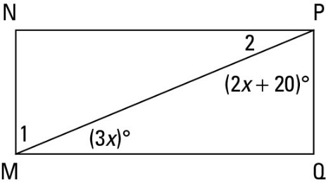

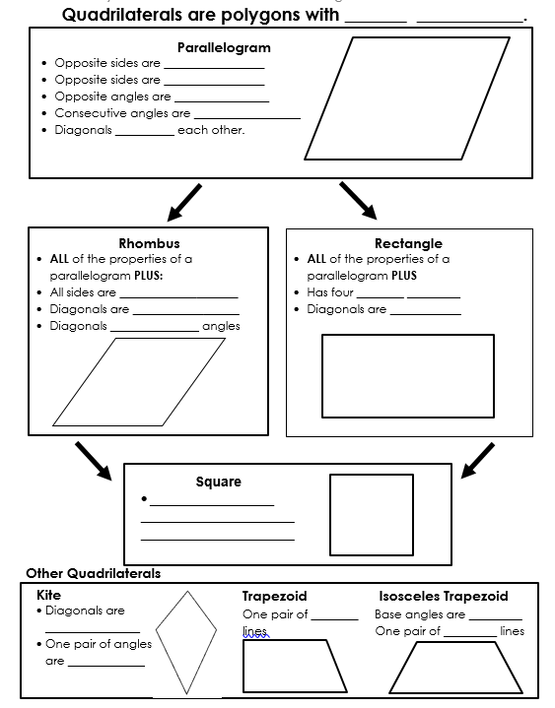
Determine whether the statement is always, sometimes, or never true.
- A rectangle is a parallelogram.
- A parallelogram is a rhombus.
- A square is a rhombus.
- A rhombus is a square.
- A rhombus is a rectangle.
- A rectangle is a square
- A quadrilateral is a rhombus
- A parallelogram is a quadrilateral
- A trapezoid is a parallelogram
- A kite is a quadrilateral
State all possible names for each quadrilateral property. Choose from:
Quadrilateral | Parallelogram | Rectangle
Rhombus | Square | Trapezoid
Kite | Isosceles Trapezoid

- Both pairs of opposite sides are parallel.
- One pair of opposite sides are parallel.
- Both pairs of opposite sides are congruent.
- Diagonals are not congruent.
- All angles are congruent.
- All angles are right angles.
- Diagonals are congruent.
- Diagonals are not congruent.
- All sides are congruent.
- Congruent consecutive sides.

