Name: ________________________________________________ Date: _________________________________

**Triangle Proportionality**

|  |  |
| --- | --- |
| If a line [parallel](https://www.varsitytutors.com/hotmath/hotmath_help/topics/parallel-perpendicular-lines.html)to one side of a [triangle](https://www.varsitytutors.com/hotmath/hotmath_help/topics/triangles.html)intersects the other two sides of the triangle, then the line divides these two sides proportionally. |  |

Solve for x:

1. 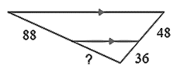
2. 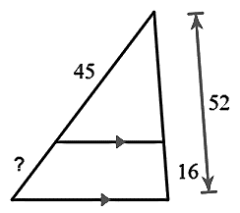

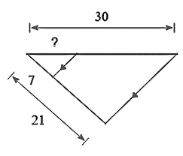

1. 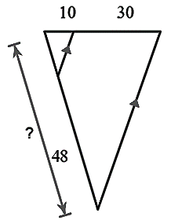

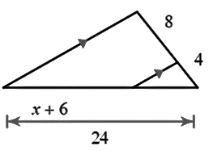

2. 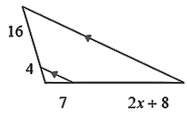

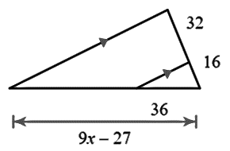

2. 