### Name: __________________________________________ Date: _____________________________

**Proofs – Proving Triangles Congruent**

**Matching: Use the choices listed at the bottom in the box for problems #1 – 4**

Problem 1:

|  |  |
| --- | --- |
| **Statement** | **Reason** |
| 1. | 1. Given |
| 2. | 2. Given |
| 3. | 3. |
| 4. ΔLMN  ΔLON | 4. |

Problem 2:

|  |  |
| --- | --- |
| **Statement** | **Reason** |
| 1. | 1. Given |
| 2. ∠R  ∠S | 2. Given |
| 3. ∠1  ∠ | 3. |
| 4. | 4. |
| 5. ΔQST  ΔTRQ | 5. |

Problem 3:

|  |  |
| --- | --- |
| **Statement** | **Reason** |
| 1. | 1. Given |
| 2. | 2. Given |
| 3. ∠GIH  ∠KIJ | 3. |
| 4. ΔGIH  Δ KIJ | 4. |

Problem 4:

|  |  |
| --- | --- |
| **Statement** | **Reason** |
| 1. | 1. Given |
| 2. ∠1  ∠4, ∠2  ∠3 | 2. |
| 3. | 3. |
| 4. ΔADC  ΔDAB | 4. |

**Choices for problems #1 – 4 (some will be used more than once):**

AAS ASA

SAS SSS

Alternate Interior Angles are ≅

Reflexive Property

Vertical Angles are ≅

***Fill in the blank proofs:***

Problem 5:

|  |  |
| --- | --- |
| **Statement** | **Reason** |
| 1. ∠I  ∠K | 1. Given |
| 2. ∠IHJ  ∠KJH | 2. Given |
| 3. | 3. |
| 4. ΔHJK  ΔJHI | 4. |

Problem 6:

|  |  |
| --- | --- |
| **Statement** | **Reason** |
| 1. ∠MLN  ∠ONL | 1. Given |
| 2. ∠OLN  ∠ _____ | 2. Given |
| 3. | 3. Reflexive Property (Given) |
| 4. ΔLNO ΔNLM | 4. |

Problem 7:

|  |  |
| --- | --- |
| **Statement**  **R** | **Reason** |
| 1. | 1. Given |
| 2. | 2. Given |
| 3. ∠PQT  ∠RQS | 3. |
| 4. ΔPQT  ΔSQR | 4. |

Problem 8:

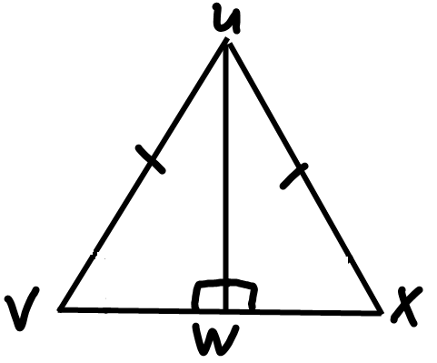

|  |  |
| --- | --- |
| **Statement** | **Reason** |
| 1. | 1. Given |
| 2. ∠VWU  ∠XWU | 2. Given |
| 3. | 3. Reflexive Property |
| 4. ΔUWV  ΔUWX | 4. |

Problem 9:

|  |  |
| --- | --- |
| **Statement** | **Reason** |
| 1. ∠Y  ∠C | 1. |
| 2. | 2. Given |
| 3. | 3. |
| 4. ΔYZA ΔCBA | 4. |

Problem 10:

|  |  |
| --- | --- |
| **Statement** | **Reason** |
| 1. ∠BAC  ∠DCA | 1. Given |
| 2. | 2. Given |
| 3. | 3. |
| 4. ΔABC  ΔCDA | 4. |

Problem 11:

|  |  |
| --- | --- |
| **Statement** | **Reason** |
| 1. ∠F  ∠I | 1. |
| 2. | 2. |
| 3. | 3. |
| 4. ΔEFG  Δ HIJ | 4. |

Problem 12:

|  |  |
| --- | --- |
| **Statement** | **Reason** |
| 1. ∠ ___  ∠M | 1. Given |
| 2. | 2. Given |
| 3. ∠KLO  ∠ _____ | 3. |
| 4. ΔKLO  ΔNLM | 4. |
| 5. ∠K  ∠N | 5. CPCTC |

Problem 13:

|  |  |
| --- | --- |
| **Statement** | **Reason** |
| 1. ∠P  ∠___ | 1. Given |
| 2. | 2. Given |
| 3. | 3. Reflexive |
| 4. ΔPQS  ΔRSQ | 4. |

Problem 14:

|  |  |
| --- | --- |
| **Statement** | **Reason** |
| 1. | 1. |
| 2. | 2. |
| 3. ∠CAD  ∠BDA | 3. |
| 4. | 4. |
| 5. ΔACD  Δ______ | 5. |