Name: ________________________________________________ Date: _______________________

**Triangle Proofs**

* Two-column geometric proofs are essentially just tables with __________________ on the left and a ____________________ on the right.
* The statements we make are going to be the _____________ we take toward solving our problem.
* Reasons can consist of information given within the problem itself, definition, postulates, or theorems.

**Statements and Reasons**

|  |  |
| --- | --- |
| **If…** | **Then the reason is…** |
| an angle or side is marked on the picture, or if it is given in the directions, |  |
| you recognize that the shapes share a side, |  |
| you see alternate interior angles, |  |
| you see vertical angles, |  |
| the statement states that the triangles are congruent, |  |
| the triangles have already been proven to be congruent, and now we are trying to prove a side or angle is congruent, |  |

**Don’t forget to ALWAYS mark your pictures!**

Example 1:

Given: Y is the midpoint of , and .

Prove: 

|  |  |
| --- | --- |
| **Statements** | **Reasons** |
| 1) |  |
| 2) |  |
| 3) Y is the midpoint of |  |
| 4) |  |
| 5) |  |

Example 2:

Given: is isosceles with legs and . Q is the midpoint of 

Prove: 

|  |  |
| --- | --- |
| **Statements** | **Reasons** |
| 1) |  |
| 2) |  |
| 3) |  |
| 4) |  |
| 5) |  |
| 6) |  |

Example 3:



Given: 

Prove: 

|  |  |
| --- | --- |
| **Statements** | **Reasons** |
| 1) |  |
| 2) |  |
| 3) |  |
| 4) |  |

Example 4:

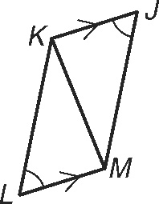

Given: 

Prove: 

|  |  |
| --- | --- |
| **Statements** | **Reasons** |
| 1) |  |
| 2) |  |
| 3) |  |
| 4) |  |
| 5) |  |