Name: ________________________________________________________ Date: _______________________

Ratios in Similar Polygons

Fill in the blanks to complete each definition.

1. A similarity ratio is the ratio of the lengths of the ____________________ sides of two similar polygons.

2. Two polygons are similar if and only if their corresponding angles are

____________________ and their corresponding sides are ___________________________.

3. Figures that are similar have the same shape but not necessarily the same

____________________.

Use the figure for Exercises 4 and 5. The triangles are similar.

4. Name the pairs of congruent angles.

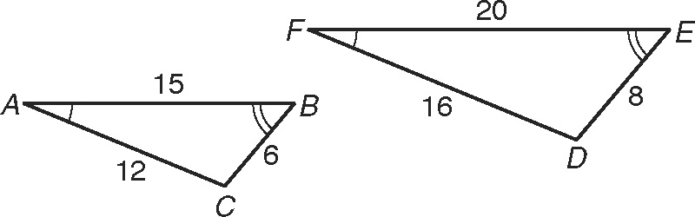

∠A ≅

∠B ≅

∠C ≅

5. Write the corresponding side lengths in the proportion. 

Use the figure to the right for Exercises 6 and 7. The triangles are similar.

6. Circle the correct similarity statement.

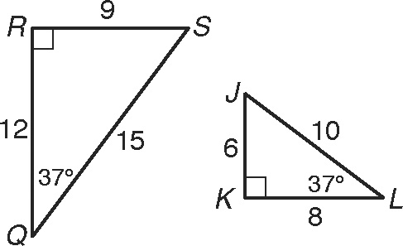

ΔQRS ~ ΔKJL ΔRSQ ~ ΔKJL ΔQSR ~ ΔLKJ

7. Write the corresponding side lengths in the proportion.   


Use the figure to the right for Exercise 8.

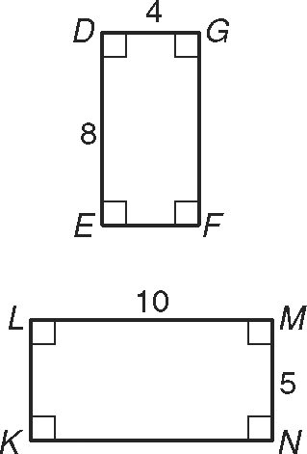

8. Substitute numbers for the side lengths and reduce each ratio to simplest form.

 = _______  = _______ = _______

**Scale Factor**

Scale Factor – the ratio of corresponding sides

* **When scale factor is greater than 1, the shape gets *bigger and* this is called an ___________________________.**
* **When scale factor is less than 1, but greater than 0, the shape gets *smaller* and this is called a _______________________.**
* **Formula: __________**

**Dilations**

Apply the dilation *D* to the polygon with the given vertices. Name the coordinates of the image points. Identify and describe the transformation as an enlargement or reduction.

9. *D* (*x*, y) →   
*A*(4, 10), *B*(–6, 4), and *C*(4, –4)

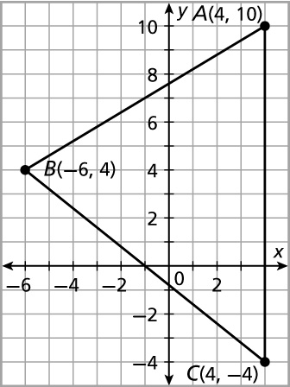

A’ _________, B’ _________, and C’ _________

This shape is a/n __________________________.

The scale factor is _________.

10. *D* (*x*, y) → (3*x*, 3*y*)

*P*(1, –1), *Q*(2, 1), *R*(–2, 1)

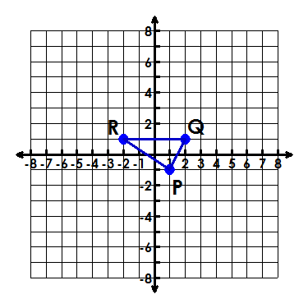

**P’ _________, Q’ _________, and R’_________**

This shape is a/n __________________________.

The scale factor is _________.