Name: ________________________________________________ Date: _______________________

**3 Ways to Prove Triangles are Similar**

**AA~ Postulate**:

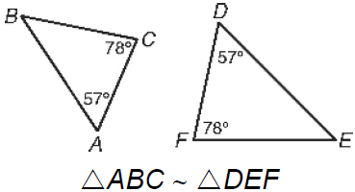

If two angles of one triangle are congruent to two angles of another, then the triangles are similar.

**SAS~ Postulate**:

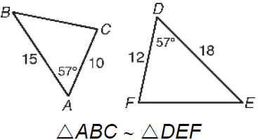

If one angle of one triangle is congruent to the one angle of another triangle and the adjacent sides are proportional, then the triangles are similar.

**SSS~ Postulate**:

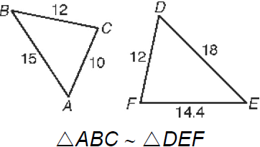

If all three sides of one triangle are proportional to corresponding sides of another triangle, then the triangles are similar.

**You can mark vertical angles and shared angles congruent!**

**Explain why the triangles are similar (SSS~, SAS~, or AA~) and write a similarity statement.**

1. RQS~__________ by ______



1. HGJ~__________ by ______



1. ABC~__________ by ______



1. ADE~__________ by ______



1. QPR~__________ by ______

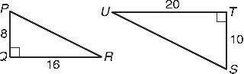

1. ABC~__________ by ______

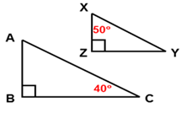

1. GHJ~__________ by ______

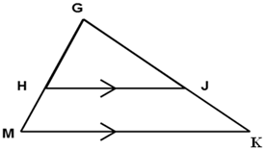

1. AEF~__________ by ______

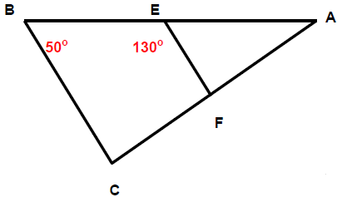

**Explain why the triangles are similar (SSS~, SAS~, or AA~) and find each length.**

9) Similar by ______ and **GK** = _____



10) Similar by ______ and **SU** = _____



11) Similar by ______ and **DE** = ____



12) Similar by ______ and **RQ** = ____

