### Name: __________________________________________ Date: _____________________________

**Vocabulary, Central Angles & Inscribed Angles**

|  |  |  |
| --- | --- | --- |
| **Circle** | set of all points equidistant  from a given point called  the center of the circle |  |
| **Chord** | a segment whose endpoints  are on the circle |  |
| **Diameter** | distance across the circle  through its center |  |
| **Radius** | distance from the center  to point on circle |  |
| **Secant** | a line that intersects the  circle at exactly TWO points |  |
| **Tangent** | a line that intersects the  circle exactly ONE time |  |
| **Point of Tangency** | where the tangent line  intersects the circle |  |

|  |  |  |
| --- | --- | --- |
| **Major Arc** | **Semicircle** | **Minor Arc** |
|  |  |  |

**BASIC REVIEW:**

* A circle has 360 degrees
* A semicircle has 180 degrees
* Vertical angles are equal
* Linear pairs are supplementary

|  |  |  |
| --- | --- | --- |
| **Central Angles** | An angle whose vertex is at  the **center** of the circle |  |
|  |

Examples**:**

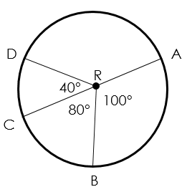

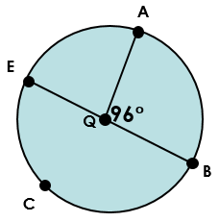

|  |  |  |
| --- | --- | --- |
| **Inscribed Angles** | An angle whose vertex is **on**  the **edge** of the circle |  |
|  |

Examples:

