### Name: __________________________________________ Date: _____________________________

**Inscribed Angles**

|  |  |  |
| --- | --- | --- |
| vertex is on the  **center** of the circle |  |  |

|  |  |  |
| --- | --- | --- |
| vertex is on the  **edge** of the circle |  |  |

|  |  |  |
| --- | --- | --- |
| If two angles intercept the same arc… |  |  |

Find the measure of angle A and angle C.

1. 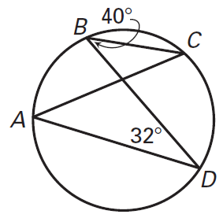
2. 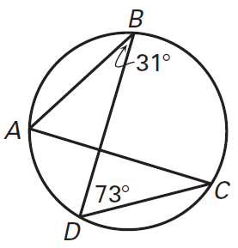
3. 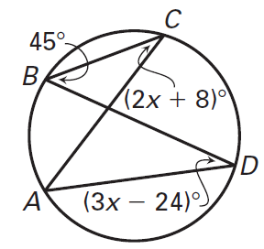

|  |  |  |
| --- | --- | --- |
| If a quadrilateral is inscribed in a circle… |  |  |

Solve for x and y.

