4.2 - Inscribed Angles

Find each measure.

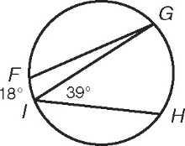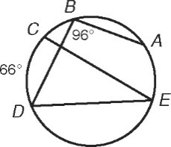 1. mCED  _________ 2. mFGI  _________

 _________  _________

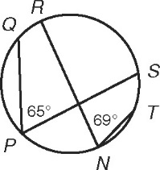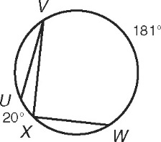 3.  _________ 4. mXVU  _________

 _________ mVXW  _________

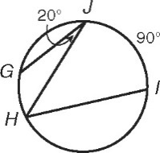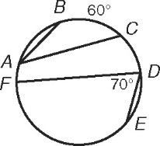 5. mBAC  __________ 6. mIHJ      __________

 __________  __________

Find each value.

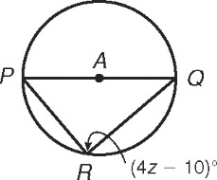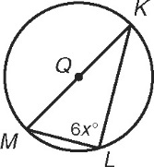 7. x  __________ 8. z  __________

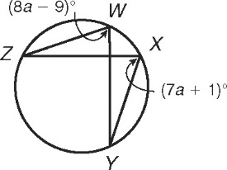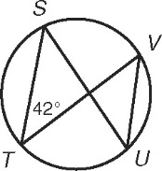 9. mVUS  __________ 10. mZWY  __________

Find the angle measures of each inscribed quadrilateral.

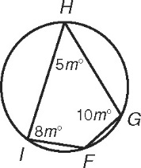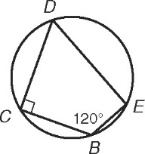 11. m*B*  __________ 12. m*F*  __________

m*C*  __________ m*G*  __________

m*D*  __________ m*H*  __________

m*E*  __________ m*I*  __________

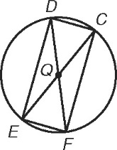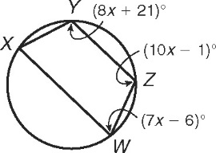 13. m*X*  ________ 14. m*C*  ________

m*Y*  ________ m*D*  ________

m*Z*  ________ m*E*  ________

m*W*  ________ m*F*  ________

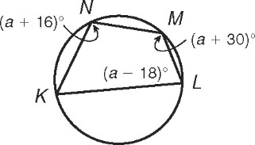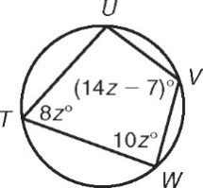 15. m*T*  ________ 16. m*K*  ________

m*U*  ________ m*L*  ________

m*V*  ________ m*M*  ________

m*W*  ________ m*N*  ________

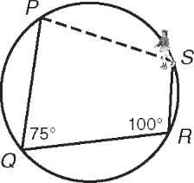 17. Lyla has not learned how to stop on ice skates yet, so she just   
skates straight across the circular rink until she hits a wall. She   
starts at P, turns 75° at Q, and turns 100° at R. Find how many   
degrees Iyla will turn at S to get back to her starting point.

_________________________