### Name: __________________________________________ Date: _____________________________

**Angles – Vertex Inside & Outside**

|  |  |  |
| --- | --- | --- |
| vertex is on the  **CENTER** of the circle |  |  |

|  |  |  |
| --- | --- | --- |
| vertex is on the  **EDGE** of the circle |  |  |

|  |  |  |
| --- | --- | --- |
| vertex is **INSIDE**  of the circle |  |  |

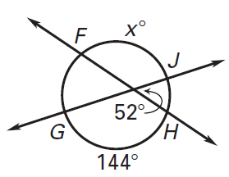Solve for x:

1. 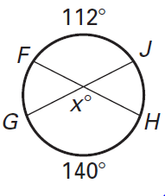
2. 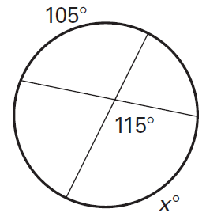

|  |  |  |
| --- | --- | --- |
| vertex is **OUTSIDE**  of the circle |  |  |

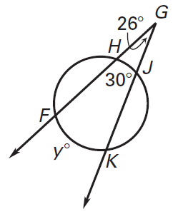Solve for the variable:

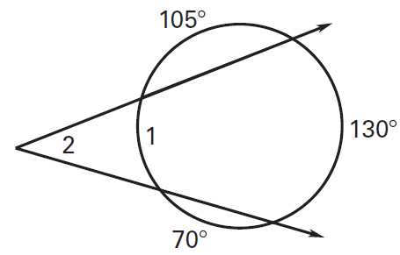

**X°**

1. 