### Name: __________________________________________ Date: _____________________________

**Segment Lengths – Tangents**

|  |
| --- |
| * If two segments from the same exterior point   are tangent to a circle, then they are congruent. |

1. 

16

3x + 4



1. 

11

x2 + 2



1. 

x2  – 15

14x



1. 



3

4

x

A

1. 



3

5

7

C

B

|  |
| --- |
| * If a line (segment or ray) is tangent to a circle,   then it is perpendicular to the radius drawn to  the point of tangency. |

1. 



12

9

x

1. 



12

8

x

1. Is CB tangent to the circle?



24

16

32

C

B

A

1. 



24

16

1. 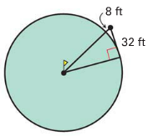A green on a golf course is in the shape of a circle. Your golf

ball is 8 feet from the edge of the green and 32 feet from a

point of tangency on the green.

* 1. 
  2. How far is your ball from the cup at the center? __________