Name: __________________________________________ Date: _____________________________

Volume of Composite Solids

Find the volume of each of the following composite functions.

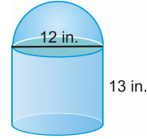

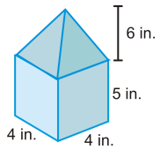

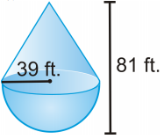

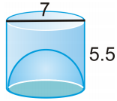
open hemisphere

Tennis balls with a 3 inch diameter are sold in cans of three. The can is a cylinder.
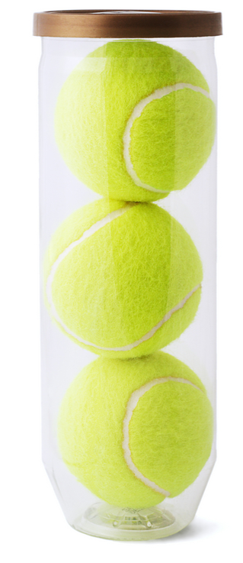
- What is the volume of one tennis ball?

- What is the volume of the cylinder?

- How much space is not occupied by the tennis balls in the can?

One hot day at a fair you buy yourself a snow cone. The
height of the cone shaped container is 5 in and its radius
is 2 in. The shave ice is perfectly rounded on top forming
a hemisphere.

- What is the volume of the ice in your frozen treat?

The volume of one ball is 288π in.³
- What is the radius of the ball?

- If 4 of the balls were stacked on top of each other, how tall would the stack be?

