Name: ___________________________________________ Date: ____________________________
Unit 6 Ladder Review

- Write the equation of the circle centered at (-4, 6) with a diameter of 16.

- Write an equation of the line that passes through (5, -3) and is perpendicular to
y = -5/2x+1.

- Write an equation of the line that passes through (2, 4) and is parallel to 4x + 2y = 8.

- Reed and Skylar are playing Hide-and-Seek. Reed runs and hides 30 ft south and 24 ft east of base. Skylar runs and hides 43 ft north and 12 ft west of base. How far apart are Skylar and Reed?

- A circular skylight has a diameter with endpoints at (−6, 32) and (2, 26). Find the center and radius of the skylight.

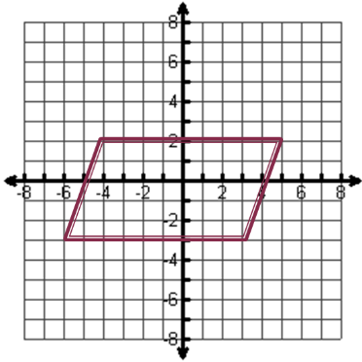
- Find the perimeter of the figure.

- Prove using distance or the slope to prove that the figure is a parallelogram.

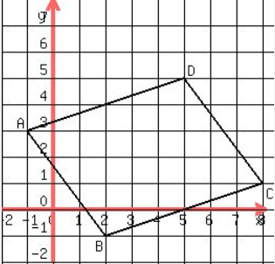

- Find a point T on the segment with endpoints C(-4, -6) and D(2, 3)
that partitions it in a 2:1 ratio.

- Put the equation of the circle in general form.

- Circle C has a center of (5, 2) and a radius of 6. Does the point (8, 7) lie on circle C?

