Name: _____________________________________________ Date: ___________________________

**Unit 6 Review**

1. Find an equation of the line that is **parallel** to y = 2x + 8 that passes through (-6, 1).
2. Find an equation of the line that is **perpendicular** to y = 3x + 1 that passes through (9, -2).

The following shape is a rectangle.

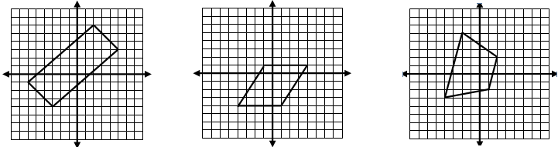

**A**

**C**

**B**

**D**

1. Prove that it’s a parallelogram using the distances and slopes.
2. The diagonals of a rhombus are perpendicular. Find the slopes of the diagonals to prove that it’s not a rhombus.
3. Find the perimeter and area of the rectangle.
4. Josh and Drake decide to play catch after school. They start at the same point. Josh walks 50 feet north and 20 feet west. Drake walks 40 feet south and 10 feet east. How far apart are they?

**Graph the following circles. State the center and radius.**

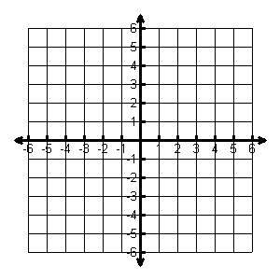

1. 

Center: _______

Radius: ______

1. 

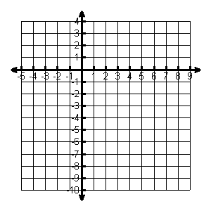

Center: _______

Radius: ______

**Write the standard equation for the circle. Write the general form for circle.**

1. 
2. 
3. A circular disk drive has a diameter with endpoints at (−9, 2) and (15, 12). Find the center and radius of the disk drive. Write the equation of the circle in standard form.

*Center: ____________*

r = _____

**Equation: ____________________________**

1. Find the **midpoint** of the points: (-5, 3) (2, 6).
2. Find the coordinates of the **other endpoint** of a segment with an endpoint of  and a midpoint.
3. Determine whether Point A lies on the circle whose center is Point C and which contains the Point P(0, 4). Justify your answer algebraically showing work.

Point A(3, √7); Point C(0, 0); Point P(0, 4)

1. Find the coordinates of point T so that it partitions AB into a ratio of 1:3.

A (-8, -1) and B(12, 11)