Name: _____________________________________________ Date: _______________________________

|  |
| --- |
|  |

**Find the midpoint of each segment.**

1. 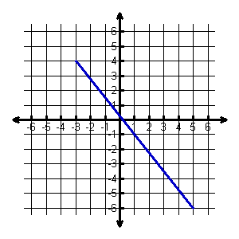Midpoint = __________
2. 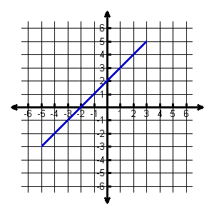Midpoint = __________
3. 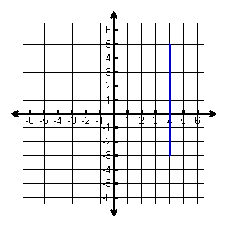Midpoint = __________
4. 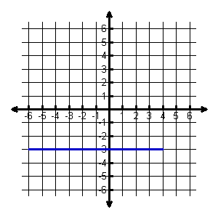Midpoint = __________
5.  and 
6.  and 
7.  and 

**Given the midpoint and one endpoint, find the other endpoint of the line segment.**

1. 
2. 
3. 