Name: _____________________________________________ Date: _______________________________

|  |
| --- |
|  |

**Find the midpoint of each segment.**

1. 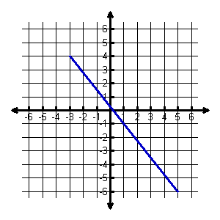Midpoint = __________
2. 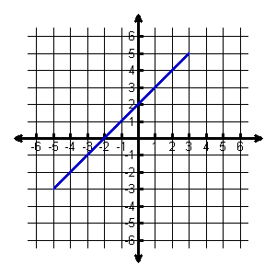Midpoint = __________
3. 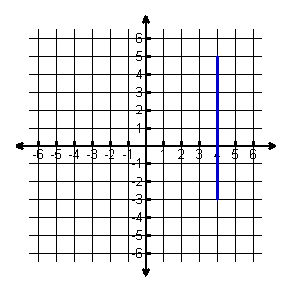Midpoint = __________
4. 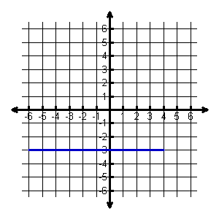Midpoint = __________
5.  and 
6.  and 
7.  and 

**Given the midpoint and one endpoint, find the other endpoint of the line segment.**

1. 
2. 
3. 

**Partitioning Line Segments in 2 Dimensions**

|  |
| --- |
|  |

1. Given the points A(–3, -2) and B(6, 1), find the coordinates of the point P on directed line segment  that partitions  in the ratio 2:1.

** **

1. Given the points A(-3, -4) and B(2, 0), find the coordinates of the point P on directed line segment  that partitions  in the ratio 2:3.

** **



1. Given the points A(-4, 4) and B(0, -4), find the

coordinates of the point P on directed line

segment  that partitions  in the ratio 1:3.



1. Given the points A(-2,1) and B(4, -4), find the

coordinates of the point P on directed line

segment  that partitions  in the ratio 2:4.