### Name: __________________________________________________________________ Date: _____________________



1. Given the points A(–1, 2) and B(7, 14), find the coordinates of the point P on directed line segment  that partitions  in the ratio 1:3.

** **

1. Given the points A(-2, 4) and B(7, -2), find the coordinates of the point P on directed line segment  that partitions  in the ratio 1:2.

** **

1. Given the points A(-5, -5) and B(5, 0), find the coordinates

of the point P on directed line segment  that partitions

 in the ratio 2:3.

** **

1. 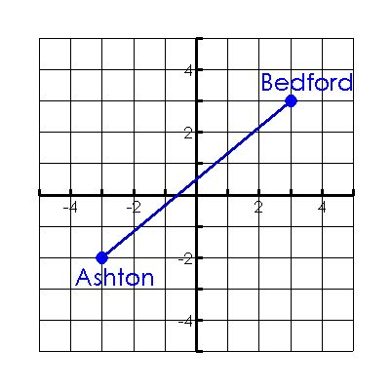The map shows a straight highway between two towns. Highway planners want to build two new rest stops between the towns so that the two rest stops divided the highway into three equal parts. Find the coordinates of the point at which the **first** rest stop should be built.

 