Name: _____________________________________ Date: ______________________________________

**Perimeter of Geometric Figures**

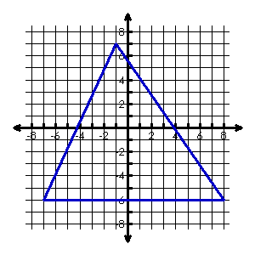Find the **perimeter** of each shape. Round to 2 decimal places.

1. 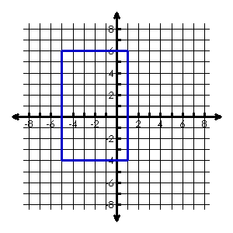

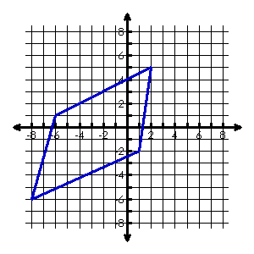

1. 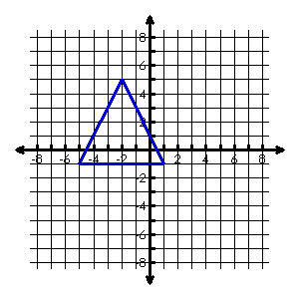

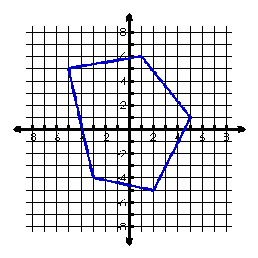

1. 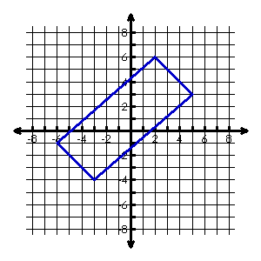

Plot the given points and find the **perimeter** of each shape. Round to 2 decimal places.

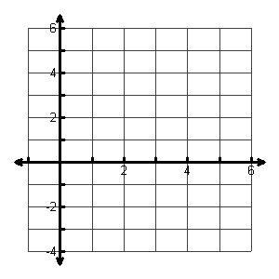

1. **A(0, –2), B(0, 2), C(4, 0)**

Perimeter:

1. 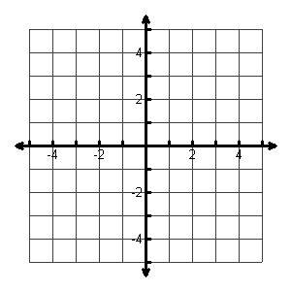**W(-3, –1), X(-1, 2), Y(4, 2), Z(2, -1)**

Perimeter:

1. **S(1, 0), R(-1, 2), G(2, 5), B(4, 3)**



Perimeter:

**Area of Geometric Figures**

Find the **area** of each shape. Round to 2 decimal places.

|  |  |  |
| --- | --- | --- |
| 1. [image] | 1. [image] | 1. [image] |

Plot the given points and find the **area** of each shape. Round to 2 decimal places.

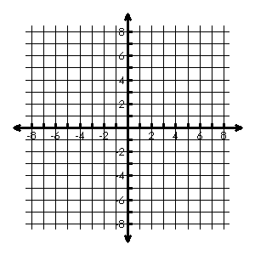

1. **A (-4, 5), B (1, 5), C (2, -1), D (-3, -1)**

Area =



1. **A (-1, 5), B (2, -1), C (-2, -3), D (-3, 4)**

Area =