### Name: _____________________________________________________________ Date: _____________________________

1. Write the equation of the line given the slope is 2 and the y-intercept is -7.
2. Find the equation of the line between the points (4, -1) and (12, 3).
3. Given the slope of a line,, and the point , write the equation of the line.
4. Given the graph, write the equation of the line.



**Write an equation of the line that is parallel to the given line and passes through the given point.**

1. 2y = 6x – 4, (0, 3)
2. 3y = x + 5, (6, 0)
3. 2x – 4y = 8, (-3, 1)

**Write an equation of the line that is perpendicular to the given line and passes through the given point.**

1. y = -7x + 5 ; (7, 1)
2. y = – 4 ; (4, 3)
3. 3x + 5y = 6 ; (-2, -2)

**Error Analysis:**

1. Keesha claimed the equation of the line through the point (4, -3) with slope 1/12 is y = 1/12x + 8. Her work is shown below. Explain her mistake and find the correct equation.

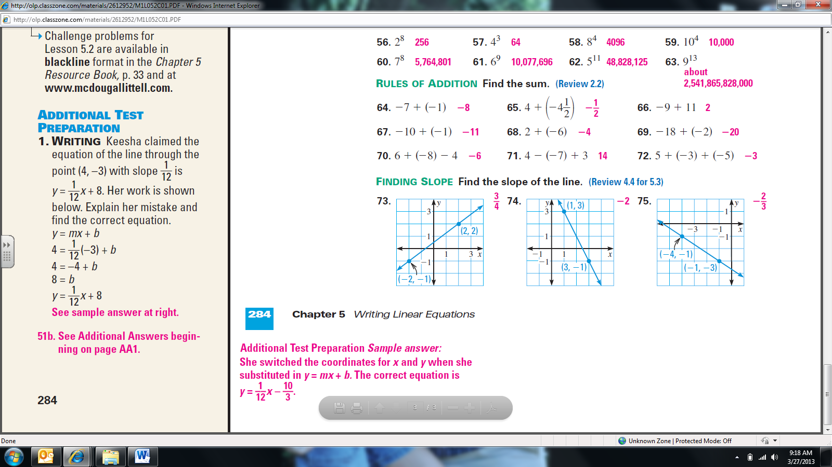

**Find the length of the missing variable:**

1. 
2. 
3. 

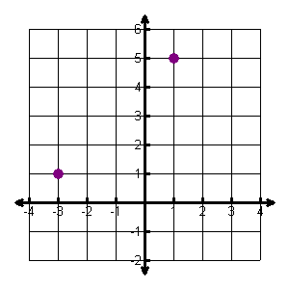

**Find the distance between the following points:**

1. 
2. 
3. Max’s bone was buried 20 miles west and 2 miles north of his dog house. If his doghouse is located at the origin, how far away is Max’s doghouse and his bone?