Name: __________________________________________ Date: _____________________________

Coordinate Geometry Proofs

Steps to Coordinate Proofs:
- Plot the points.
- Look for key words.
Parallel, Perpendicular, Right Angles – Use _____________ Congruent Sides – Use _____________

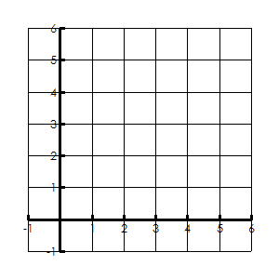Example 1: The coordinates of triangle BCD are B(4, 2), C(0, 2), and D(2, 4).
Prove that the triangle is an isosceles triangle.
- What is the question asking you about?
Parallel OR Perpendicular OR Distance
- BC=
CD=
DB=
- Is triangle BCD isosceles? How do you know?

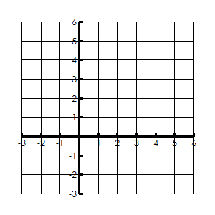Example 2: Triangle ABC has coordinates A(-1, 3), B(5, 5), and C(4, -2).
Prove that the triangle is an equilateral triangle.
- What is the question asking you about?
Parallel OR Perpendicular OR Distance
- AB=
BC=
CA=

- Is triangle ABC equilateral? How do you know?

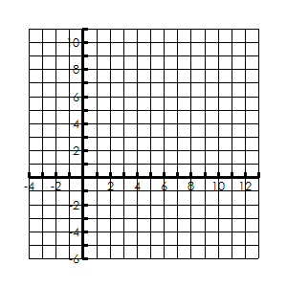Example 3: A rectangle has two pairs of opposite sides that are congruent.
Quadrilateral MIKE has vertices M(4, 1), I(6, 4), K(12, 0), and E(10, -3). Prove that Quadrilateral MIKE is a rectangle.
- What is the question asking you about?
Parallel OR Perpendicular OR Distance
- MI=
IK=
KE=
EM=

- Is MIKE a rectangle? How do you know?

Example 3b: A rectangle has 4 right angles.
Quadrilateral MIKE has vertices M(4, 1), I(6, 4), K(12, 0), and E(10, -3). Prove that Quadrilateral MIKE is a rectangle.
- What is the question asking you about?
Parallel OR Perpendicular OR Distance
- MI=
IK=
KE=
EM=

- Is MIKE a rectangle? How do you know?

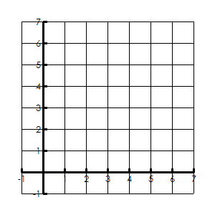Example 4: A square has four congruent sides.
Quadrilateral DIAN has vertices D(0, 5), I(3, 6), A(4, 3) and N(1, 2).
Prove that Quadrilateral DIAN is a square.

- What is the question asking you about?
Parallel OR Perpendicular OR Distance

- DI=
IA=
AN=
ND=
- Is DIAN a square? How do you know?

Example 4b: A rhombus has perpendicular diagonals.
Quadrilateral DIAN has vertices D(0, 5), I(3, 6), A(4, 3) and N(1, 2).
Prove that Quadrilateral DIAN is a rhombus.

- What is the question asking you about?
Parallel OR Perpendicular OR Distance

- DA=

IN=

- Is DIAN a rhombus? How do you know?

