### Name: __________________________________________ Date: _____________________________

**Coordinate Geometry Proofs using Slope and Distance**

1. **The vertices of triangle JEN are J(2, 10), E(6, 4), and N(12, 8). Prove that JEN is an isosceles right triangle.**

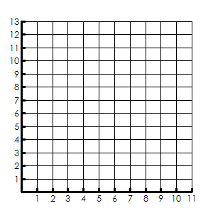

1. How do you prove it is isosceles? _____________________

**JE= EN= NJ=**

1. How do you prove it is a right triangle? ________________

**JE= EN= NJ=**

1. Is JEN an isosceles right triangle? How do you know?
2. **A parallelogram has opposite sides congruent and parallel. The vertices of quadrilateral JOHN are J(-3, 1), O(3, 3), H(5, 7), and N(-1, 5). Prove that JOHN is a parallelogram.**

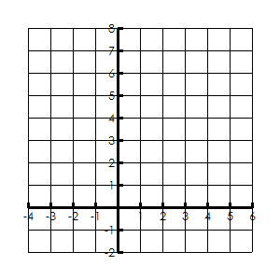

1. How do you prove opposite sides are congruent? ________________________________________________

**JO= HN=**

**OH= NJ=**

1. How do you prove opposite sides are parallel? ____________________________________________

**JO= HN=**

**OH= NJ=**

1. Is JOHN a parallelogram? How do you know?
2. **Prove that quadrilateral 𝐿𝐸𝐴𝑃 with the vertices 𝐿(−3,1),𝐸(2,6),𝐴(9,5) 𝑎𝑛𝑑 𝑃(4,0) is a parallelogram.**

Does it have another name? _______



1. **The points (0,0), 𝐴(−4,1), 𝐵(−3,5), and 𝐶(1,4) are the vertices of parallelogram 𝑂𝐴𝐵𝐶. Is this parallelogram a rectangle? Support you answer.**



1. **Given: 𝐴(−2,2),𝐵(6,5),𝐶(4,0),𝑎𝑛𝑑 𝐷(−4,−3). Prove: 𝐴𝐵𝐶𝐷 is a parallelogram but not a rectangle.**

