Name: _________________________________________________ Date: ______________________________

**Equations of Circles**

**Standard Form of a Circle**

**General Form of a Circle**

1. Write an equation of a circle with center (3, -2) and a radius of 4.
2. Write an equation of a circle with center (-4, 0) and a diameter of 10.
3. Write an equation of a circle with center (2, -9) and a radius of .
4. Find the coordinates of the center and the measure of the radius. 

**Find center, radius, & equation of the circle.**



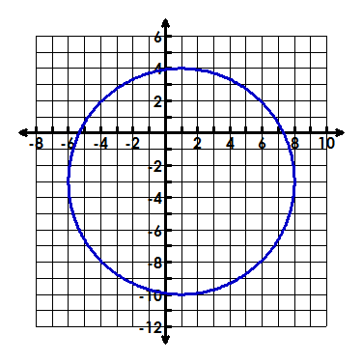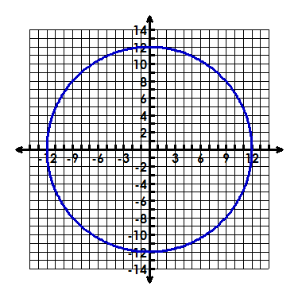



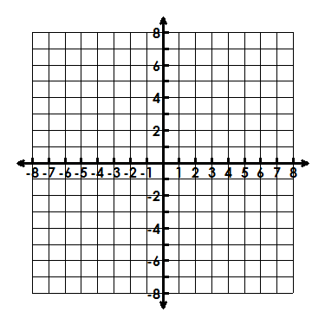**Graph the circle, identify the center & radius.**

1. 