### Name: __________________________________________________________________ Date: _____________________

**Unit 1 EOC Practice Problems**

1. Consider the expression 3n2 + n + 2. Identify the coefficients and terms.
2. Is the sum of  rational or irrational?
3. Is the sum of 0.0675675675… and 8 rational or irrational?
4. The formula for density is d = m/v, where m is mass and v is volume. If mass is measured in kilograms and volume is measured in cubic meters, what is the unit for density?
5. A rectangle has a length of 2 meters and a width of 40 centimeters. What is the perimeter of the rectangle?
6. Look at one of the formulas for the perimeter of a rectangle where l represents the length and w represents the width: 2(l + w). What does the 2 represent?
7. The dimensions of a rectangle are shown. What is the perimeter, in units, of the rectangle?

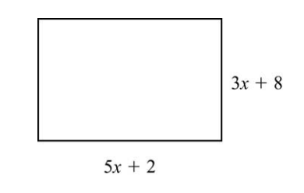

1. The dimensions of a patio, in feet, are shown below. What is the area of the patio in square feet?

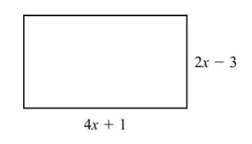

1. Which sum is rational?

A.  B.  C.  D. 

1. Which product is irrational?
2.  B.  C.  D. 
3. A rectangle has a length of 12 meters and a width of 400 centimeters. What is the perimeter, in cm, of the rectangle?

A. 824 cm B. 1600 cm C. 2000 cm D. 3200 cm

1. Jill swam 200 meters in 2 minutes 42 seconds. If each lap is 50 meters long, which is most likely to be her time, in seconds, per lap?
2. 32 seconds B. 40 seconds C. 48 seconds D. 60 secs
3. In which expression is the coefficient of term “n” -1?
   1. 3n2 + 4n – 1
   2. -n2 + 5n + 4
   3. -2n2 – n + 5
   4. 4n2 + n – 5
4. Convert 1500 dm to hm.
5. Convert 24.3 kL to L.
6. Convert 12 miles to inches.
7. Convert 3 mi/ hr to ft/ sec.

|  |  |  |  |  |  |  |  |
| --- | --- | --- | --- | --- | --- | --- | --- |
| 1. Solve for **x**: | | | | | | | |
| A. |  | B. |  | C. |  | D. |  |

|  |  |  |  |  |  |  |  |
| --- | --- | --- | --- | --- | --- | --- | --- |
| 1. Solve the equation: | | | | | | | |
| A. |  | B. |  | C. |  | D. |  |

|  |  |  |  |  |  |  |  |
| --- | --- | --- | --- | --- | --- | --- | --- |
| 1. What is the constant? | | | | | | | |
| A. | 15 | B. |  | C. |  | D. | 11 |

|  |  |  |  |
| --- | --- | --- | --- |
| 1. Which of the following is **NOT** a verbal expression for ? | | | |
| A. | The difference of 13 and a number | C. | A number less than 13 |
| B. | 13 decreased by a number | D. | A number take away 13 |