Name: __________________________________________________________________ Date: _____________________
EOC Practice Problems

- Consider the equations y = 2x – 3 and y = -x + 6.
  - Create a table for each equation.

  - Is there an ordered pair that satisfies both equations? If so, what is it?

- Rebecca has five coins worth 65 cents in her pocket. If she only has quarters and nickels, how many quarters does she have? Use a system of equations to arrive at your answer and show all steps.

- Peg and Larry purchased “no contract” cell phones. Peg’s phone costs $25 plus $0.25 per minute. Larry’s phone costs $35 plus $0.20 per minute. After how many minutes of use will Peg’s phone cost more than Larry’s phone?

- Is (3, -1) a solution of this system?
y = 2 – x
3 – 2y = 2x

- Solve this system.
x – 3y = 6
-x + 3y = -6

- Solve this system.
-3x – y = 10
3x + y = -8

- Each week, Tim wants to increase the number of sit-ups he does daily by 2 sit-ups. The first week, he does 15 sit-ups each day.

Write an explicit function in the form f(n) = mn + b to represent the number of sit-ups, f(n), Tim does daily in week n.

- A manufacturer keeps track of her monthly costs by using a “cost function” that assigns a total cost for a given number of manufactured items, x. The function is C(x) = 5000 + 1.3x.
  - What is the reasonable domain of the function?
  - What is the cost of 2000 items?
  - If costs must be kept below $10,000 this month, what is the greatest number of items she can manufacture?

- Consider the first six terms of this sequence: 1, 3, 9, 27, 81, 243, …
  - What is a₁? What is a₃?
  - What is the reasonable domain of the function?
  - If the sequence defines a function, what is the range?
  - What is the common ratio of the function?

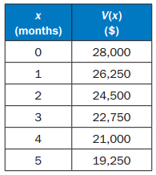
- A company uses the function V(x) = 28,000 – 1750x to represent the amount left to pay on a truck, where V(x) is the amount left to pay on the truck, in dollars, and x is the number of months after its purchase. Use the table of values shown below.

  - What is the y-intercept of the function in terms of the amount left to pay on the truck?
  - Does the graph of the function have an x-intercept, and if so what does that represent?
  - Does the function increase or decrease?

- This equation can be used to find h, the number of hours it will take Flo and Bryan to mow their lawn.

How many hours will it take them to mow their lawn?

- 6 hours B. 3 hours C. 2 hours D. 1 hour

- For what values of x is the inequality true?

A. x < 1 B. x > 1 C. x < 5 D. x > 5

- Look at the steps used when solving 3(x – 2) = 3 for x.
3(x – 2) = 3 | Original Equation
3x – 6 = 3 | Distributive Property
3x – 6 + 6 = 3 + 6 | Step 1
3x = 9 | Step 2
3x/3 = 9/3 | Step 3
x = 3 | Step 4

Which step is the result of combining like terms?

- Step 1
- Step 2
- Step 3
- Step 4

- A manger is comparing the cost of buying baseball caps from two different companies.

  - Company X charges a $50 fee plus $7 per baseball cap.
  - Company Y charges a $30 fee plus $9 per baseball cap.

For what number of baseball caps will the cost be the same at both companies?

A. 10 B. 20 C. 40 D. 100

- A shop sells one-pound bags of peanuts for $2 and three-pound bags of peanuts for $5. If 9 bags are purchased for a total cost of $36, how many three-pound bags were purchased.

- 3 B. 6 C. 9 D. 18

- Which function represents the sequence?
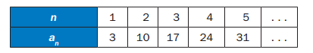
  - f(n) = n + 3
  - f(n) = 7n – 4
  - f(n) = 3n + 7
  - f(n) = n + 7

- Look at the sequence in this table.
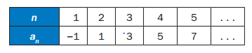
Which function represents the sequence?

  - a_{n} = a_{n – 1} + 1
  - a_{n} = a_{n – 1} + 2
  - a_{n} = 2a_{n – 1} – 1
  - a_{n} = 2a_{n – 1} – 3
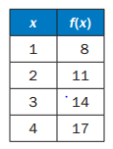
- Which functions is modeled in this table?

  - f(x) = x + 7
  - f(x) = x + 9
  - f(x) = 2x + 5
  - f(x) = 3x + 5

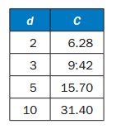
- Which explicit formula describes the pattern in this table?

- d = 3.14 x C
- 3.14 x C = d
- 31.4 x 10 = C
- C = 3.14 x d

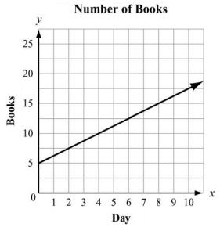
- Juan and Patti decided to see who could read more books in a month. They began to keep track after Patti had already read 5 books that month. This graph shows the number of books Patti read for the next 10 days and the rate at which she will read for the rest of the month.

If Juan does not read any books before day 4 and he starts reading at the same rate as Patti for the rest of the month, how many books will he have rea by day 12?

  - 5
  - 10
  - 15
  - 20

