Name: __________________________________________________________________ Date: _____________________
EOC Practice Problems

- Factor the expression 16a² – 81.

- Factor the expression 12x² + 14x – 6.

Solve using the best method:

- 3x² – 147 = 0

- x² – x = 12

- 5x² – 6x – 8 = 0

- What is a common factor for the expression 24x² + 16x + 144?

- 16 B. 8x C. 3x² + 2x + 18 D. 8(x – 2)(3x² + 9)

- Which of these shows the complete factorization of 6x²y² – 9xy – 42?

A. 3(2xy² – 7)(xy² + 2) C. 3(2xy – 7)(xy + 2)

B. (3xy + 6)(2xy – 7) D. (3xy² + 6)(2xy² – 7)

- What are the zeros of the function represented by the quadratic expression 2x² + x – 3?

- x = -3/2 and x = 1 C. x = -1 and x = 2/3

- x = -2/3 and x = 1 D. x = -1 and x = -3/2

- Which of these is the result of completing the square for the expression x² + 8x – 30?

A. (x+4)² – 30 B. (x+4)² – 46 C. (x+8)² – 30 D. (x+8)² – 94

- A garden measuring 8ft by 12ft will have a walkway around it. The walkway has a uniform width, and the area covered by the garden and the walkway is 192 square feet. What is the width of the walkway?

- 2ft B. 3.5ft C. 4ft D. 6ft

- The formula for the area of a circle is A = πr². Which equation shows the formula in terms of r?

  - 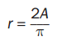 B. 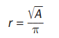 C. 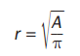 D. 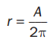

- What are the solutions to the equation 2x² – 2x – 12 = 0?

  - x = -4, x = 3 B. x = -3, x = 4 C. x = -2, x = 3 D. x = -6, x = 2

- What are the solutions to the equation 6x² – x – 40 = 0

- x = -8/3, x = -5/2 C. x = -8/3, x = 5/2

- x = 5/2, x = 8/3 D. x = -5/2, x = 8/3

- An object is thrown in the air with an initial velocity of 5 m/s from a height of 9m. The equation h(t) = -4.9t² + 5t + 9 models the height of the object in meters after t seconds.

About how many seconds does it take for the object to hit the ground? Round your answer to the nearest tenth of a second.

  - 0.940 secs B. 1.50 secs C. 2.00 secs D. 9.00 secs

- What explicit expression can be used to find the next term in this sequence?
2, 8, 18, 32, 50, …

  - 2n B. 2n + 6 C. 2n² D. 2n² + 1

- Which of these is an even function?

  - f(x) = 5x² – x B. f(x) = 3x³ + x C. f(x) = 6x² – 8 D. f(x) = 4x³ + 2x²

- Which statement BEST describes how the graph of g(x) = -3x² compares to the graph of f(x) = x²?

  - The graph of g(x) is a vertical stretch of f(x) by a factor of 3.
  - The graph of g(x) is a reflection of f(x) across the x-axis.
  - The graph of g(x) is a vertical shrink of f(x) by a factor of 1/3 and a reflection across the x-axis.
  - The graph of g(x) is a vertical stretch of f(x) by a factor of 3 and a reflection across the x-axis.

- What is the end behavior of the graph of f(x) = -0.25x² – 2x + 1?

  - As x increases, f(x) increases. As x decreases, f(x) decreases.
  - As x increases, f(x) decreases. As x decreases, f(x) decreases.
  - As x increases, f(x) increases. As x decreases, f(x) increases.
  - As x increases, f(x) decreases. As x decreases, f(x) increases.
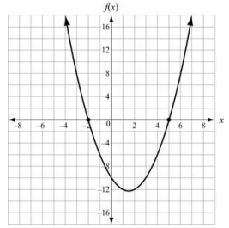
- Use the graph to answer the question.

Which function is shown in the graph?

  - f(x) = x² – 3x – 10
  - f(x) = x² + 3x – 10
  - f(x) = x² + x – 12
  - f(x) = x² – 5x – 8

- The function f(t) = -16t² + 64t + 5 models the height of a ball that was hit into the air, where t is measured in seconds and h is the height in feet. This table represents the height, g(t), of a second ball that was thrown into the air.

Which statement BEST compares the length of time each ball is in the air?
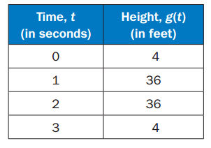
- The ball represented by f(t) is in the air for about 5 seconds, and the ball represented by g(t) is in the air for about 3 seconds.
- The ball represented by f(t) is in the air for about 3 seconds, and the ball represented by g(t) is in the air for about 5 seconds.
- The ball represented by f(t) is in the air for about 3 seconds, and the ball represented by g(t) is in the air for about 4 seconds.
- The ball represented by f(t) is in the air for about 4 seconds, and the ball represented by g(t) is in the air for about 3 seconds.

