Name: __________________________________________________________________ Date: _____________________
EOC Practice Test

- Sandra sells necklaces at a school craft fair. She uses the equation P = 7.5n – (2.25n + 15) to determine her total profit at the fair. Based on this equation, how much does she charge for each necklace?

- $2.25 B. $7.50 C. $15.00 D. $17.25

- The perimeter of a rectangle is P = 2w + 2l where w is the width of the rectangle and l is the length of the rectangle. Rearrange this formula to find the width of the rectangle.

- w = P – 2l B. 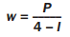 C. w = 2P – l D. 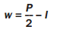

- The Mascot Company wants to spend no more than $1,250 dollars per month on the cost of school spirit items for sporting events. Production costs are 5 dollars per shirt and 8 dollars per banner. The company wants monthly gross revenue from selling shirts and banners to be greater than $3,000. One shirt sells for $15 and 1 banner sells fro $20.

An employee at the company wants to determine the number of shirts and banners that Mascot Company should produce for a month. He lets s represent the number of shirts and b represent the number of banners. He writes the following system of inequalities.
5s + 8b > 1250
15s + 20b > 3000

Part A: Does the first inequality correctly model the company’s monthly costs? Explain.

Part B: Does the second inequality correctly model the company’s monthly revenue? Explain.

- Vicky is studying French. She spends 1 hour reviewing each old chapter. She also spends 1.5 hours learning each new chapter. She spends at least 10 hours per week studying French. Which graph could represent the possible number of old chapters Vicky reviews, x, and new chapters Vicky learns, y, each week?

  - 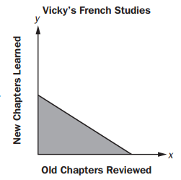 B. 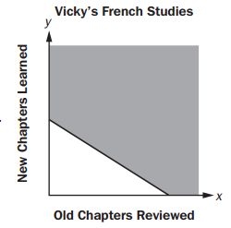

- 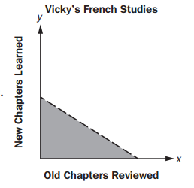 D. 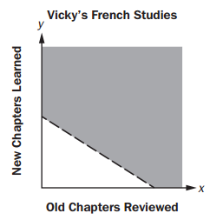

- The set of ordered pairs shown represents a function.

{(-5, 3), (4, 9), (3, -2), (0, 6)}

Select THREE ordered pairs that could be added to the set so that f remains a function.

- (-3, -2) B. (4, 0) C. (0, -1) D. (1, 6) E. (2, 3) F. (-5, 9)

- Kim uses these steps to solve a system of linear equations.
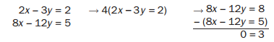
Part A: Explain the steps Kim used to obtain her result.

Part B: What can you conclude about the system of linear equations based on Kim’s result?

- It takes Matt 20 months to save $1000.

Part A: Write an equation that models the average number of dollars, x, Matt saves each month.

Part B: How much money, in dollars, did Matt save each month?

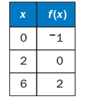
- Which function can be used to model the data in this table?

  - f(x) = 3x
  - f(x) = x/2 – 1
  - f(x) = x – 1
  - f(x) = 2x – 1

- Amy owns a graphic design store. She purchases a new printer to use in her store. The printer depreciates by a fixed rate of 14% per year. The function V = 2400(1-0.14)^{t} can be used to model the value of the printer in dollars after t years.

Part A: Explain what the parameter 2400 represents in the equation.

Part B: What is the factor by which the printer depreciates each year?

Part C: Amy also considered purchasing a printer that costs $4000 and depreciates by 25% each year. Which printer will have more value in 5 years?

Part D: Amy wants to replace the printer after 6 years. She wants to sell her current printer and make a $150 profit over the value of the printer after 6 years. At what price will she need to sell the printer to make a $150 profit on the sale?

- The function f(x) = x – 9 is shifted 2 units up and 3 units to the left. Select the new function.

  - g(x) = 2x – 6 B. g(x) = (x - 3) + 7 C. g(x) = 3x – 7 D. g(x) = (x + 3) – 7

- A scientist studied the relationship between the number of trees, x, per acre and the number of birds, y, per acre in a neighborhood. She modeled the relationship with a scatter plot and used the equation y = 4 + 6x for the regression line. What is the meaning of the slope and y-intercept of this regression line?

  - The slope is 6. This means that the average number of birds per acre in an area with no trees is 6. The y-intercept is 4. This means that for every 1 additional tree, she can expect an average of 4 additional birds per acre.
  - The slope is 4. This means that for every 1 additional tree, she can expect an average of 4 additional birds per acre. The y-intercept is 6. The average number of birds per acre in an area with no trees is 6.
  - The slope is 6. This means that for every 1 additional tree, she can expect an average of 6 additional birds per acre. The y-intercept is 4. The average number of birds per acre in an area with no trees is 4.
  - The slope is 4. This means that the average number of birds per acre in an area with no trees is 4. The y-intercept is 6. This means that for every 1 additional tree, she can expect an average of 6 additional birds per acre.

- A random group of high school students was surveyed. Each student was asked whether it should be mandatory for all high school students to participate in a sport. The results are partially summarized in the two-way table.
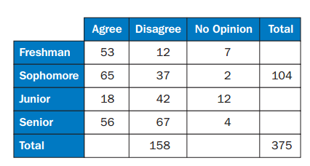
In the freshman group, what percentage of students agree that it should be mandatory for all students to participate in a sport?

  - 14.1%
  - 22.6%
  - 53%
  - 73.6%

- Maria and Jeff collect data on the number of cars that pass through an intersection every Monday morning for 2 months. They record the findings as 78, 158, 63, 71, 56, 67, 75, and 64. They each use different methods to summarize the typical number of cars that pass through the intersection at the specified time and compare their findings. Jeff says that on average, 79 cars pass through the intersection each Monday morning. Maria disagrees and says that the mean cannot be used and uses the median instead to describe the number of cars that pass through the intersection on a given Monday morning. She says that 69 cars through the intersection.

Part A: Whose method BEST describes the center of the data?

Part B: Justify your answer.

- Which value is an irrational number?

  - 4 + √7 B. (√2)(√8) C. (√3√12)/5 D. √3 - √3

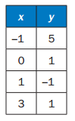
- The table defines a quadratic function. What is the average rate of change between x = -1 and x = 1?

  - Undefined
  - -1/3
  - -3
  - -4

- A quadratic function is shown: f(x) = x² + 8x + 15

Part A: What is the factored form of f(x) that reveals the zeros of the function?

  - f(x) = (x + 4)(x + 2)
  - f(x) = (x + 3)(x + 5)
  - f(x) = (x + 2)(x + 6)
  - f(x) = (x + 1)(x + 15)

Part B: What is the equivalent form of f(x) that reveals the minimum of the function?

- f(x) = (x + 4)² – 1
- f(x) = (x + 3)²
- f(x) = (x + 2)² + 3
- f(x) = (x + 1)² + 8

- Extended Constructed-Response

Part A: What are the zeros of the function f(x) = x² – 6x + 8? Explain how you determined your answer.

Part B: Arturo made an error when finding the minimum value of the function g(x) = x² – 6x + 10. His work is shown below.
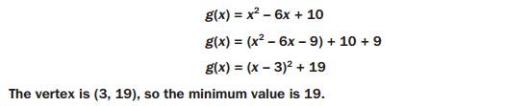
Describe the error that Arturo made. Then give the correct minimum value of the function.

- Shaun recycles bottles and cans. He earns 10 cents for each bottle he recycles and 5 cents for each can he recycles. After recycling a bag of bottles and cans, he gets a receipt that states he earned $12.75 and recycled a total of 210 bottles and cans. To determine the number of bottles and the number of cans he recycled, Shaun writes the system of equations below.

x + y = 210
10x + 5y = 1275

Part A: Explain how you know that x represents the number of bottles Shaun recycled.

Part B: Shaun graphs lines to represent the equations in his system. What are the coordinates of the point where the 2 lines intersect?

- The total area of two rectangles can be represented by the expression x(3x + 1) + 2x(x + 3). Which expression represents the total area of the two rectangles combined?

  - 7x² B. 6x³ + 6x² C. 6x² + 7x D. 5x² + 7x

- Lamar is knitting a scarf at a constant rate. He makes each row of the scarf 1-foot-wide and finishes and entire row before starting the next row. At various times, he records how long he’s been knitting and the length of the scarf. After knitting for a total of 11 hours, he records the length of his scarf. Then, he stops and makes this graph.

The finished scarf will be about 6 feet long and 1 foot wide. He estimates he is about 75% finished.

Part A: Lamar determines the rate at which he is knitting by calculating the slope of the graph. The slope of the graph is about 0.4. Explain why the unit rate for the graph could be 0.4 feet per hour. Explain why the unit rate for the graph could also be 0.4 square feet per hour.

Part B: Lamar decides to represent his unit rate in 0.4 feet per hour. Explain how he could convert his rate to inches per hour.

- The graph of the exponential function f(x) = 4(0.5)^{x} + 2 is shown.
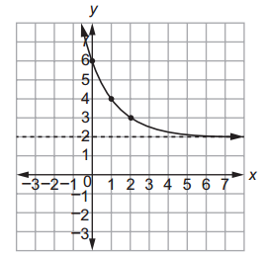

Part A: Which function has the same end behavior for large, positive values of x?

  - f(x) = 4(1.1)^{x} + 3
  - f(x) = 0.5(1.1)^{x} + 2
  - f(x) = 4(0.8)^{x} + 3
  - f(x) = 0.5(0.8)^{x} + 2

Part B: Select TWO functions whose graphs have a y-intercept of 1.

- h(x) = 5(2)^{x}
- f(x) = 5(0.5)^{x} + 0.5
- f(x) = (2)^{x}
- f(x) = (0.5)^{x} + 1
- f(x) = 0.5(2)^{x} + 0.5

